Collaboration platform technical specifications

Document release

|  |  |  |
| --- | --- | --- |
|  | Created | Reviewed |
| Name | Chihab JRAOUI |  |
| Date | 26 February 2021 |  |
| Signature |  |  |

Contents

1. Collaboration Platform Requirements 3

1.1. New features 3

1.2. Global optimizations 3

1.3. Feature #1: Follow / unfollow feature 3

# Collaboration Platform Requirements

## New features

After we finished the first version the collaboration platform. We saw the need of adding new features and expanding the platform. We saw also that this platform is limited to only collaboration is not enough.

We decided to add the following features (more to be added) :

* Follow / unfollow members.

## Global optimizations

In order to continue our work in the collaboration platform, we need first to optimize and clean up the project.

* Database schema organization
* Back-end project clean up
* Front-end project clean up

## Feature #1: Follow / unfollow feature

We want our platform to be like a collaboration space where team members can share their resources and discuss their ideas. But the user does not need to see all what the other members of his company have shared, this is why we need to give him the ability to follow and see only the members that he chooses to.

Exactly like social media platforms, this feature allows the user to open the profile of the desired member and follow him/her.

Certain modifications need to be done in the current database structure in order to begin developing this functionality:

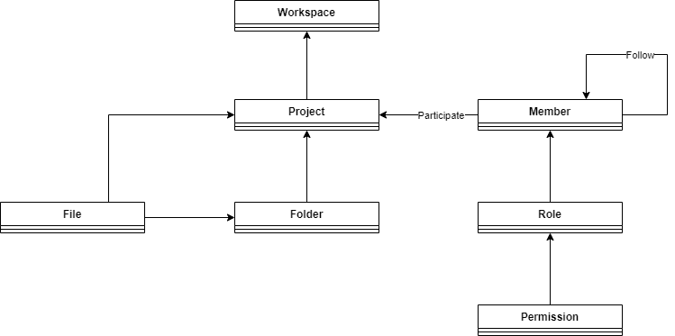

Notice that we added the relationship “follow” from the Member entity to itself.